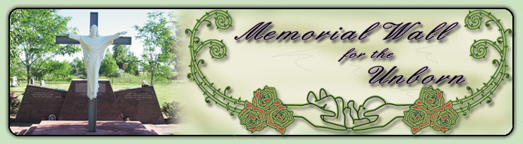
Sacred Heart of Mary Church
6739 South Boulder Road
Boulder, CO 80303
303-499-8989 x256
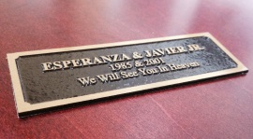

To order a plaque: https://www.sacredheartofmary.org/memorial-wall
Sacred Heart of Mary - Brass Name Plates
The National Memorial for the Unborn (NMU) and Sacred Heart of Mary (SHM) give you the opportunity to honor your child by purchasing a brass name plate to be placed on the NMU Wall of Names and/or the Sacred Heart of Mary Memorial Wall. You can join thousands from across the country who have taken an important step in the healing process.
Plate Options
Standard Option: $45.00 - Includes two 1" x 3.5" plates.
One plate will be placed on the Wall of Names by NMU staff.
One plate will be given to you by SHM staff for your personal remembrance.
Standard Option +1: $55.00 - Includes three 1" x 3.5" plates.
One plate will be placed on the Wall of Names by NMU staff.
One plate will be placed on the SHM Memorial Wall by SHM staff.
One plate will be given to you by SHM staff for your personal remembrance.
*Exception: Miscarriage/stillborn plates will only be placed on SHM Memorial Wall

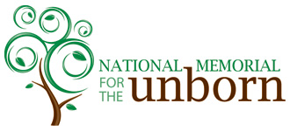
No Longer nameless, nor forgotten . . .
Honored with dignity

6230 Vance Rd, Chattanooga, TN 37421
Phone Number: (800) 505-5565 or (423) 899-1677
www.memorialfortheunborn.org

